UNSW Centre for Primary Health Care and Equity Annual Forum Live Stream
30th August 2022 9:00am – 11:30 am

Theme: Refugee and Immigrant Health

First session: 9:00–10:20am – Opening address & key speaker’s presentation
9.00 | Opening address: Year in review  By Prof Mark Harris, Exec Director, CPHCE
9.10 - | Ian Webster “Health for All” Oration - Theme: Refugee and Immigrant Health  By Dr Mitchell Smith, Ms Sundus Yousif  ‘There will be 10 min for Questions
10.10 | 10 minutes break

Second session: 10:20– 11:30am – Three presentations on panel member discussion & CPHCE Awards
 | 10:20 | Introduction  By A/Prof Fiona Haigh, CPHCE
 | 10:23 | “Fragmented care”: Asylum seekers’ access to health care in New South Wales  By Dr Zelalem Mengesha, CPHCE
 | 10:33 | Refugee place-making in high-income resettlement countries: what contributes to health and wellbeing?  By Dr Esther Alloun, CPHCE
 | 10:43 | Optimise -links to navigation roles  By Prof Mark Harris, Sabuj Kanti Mistry, CPHCE
 | 10.53 | Questions
 | 10:58 | Panel member discussion with:  Dr Mitchell Smith, Director, NSW Refugee Health Service  Ms Sundus Yousif, SWSLHD Bi-Lingual Community Educator  Lisa Woodland, Director, South-Eastern Sydney Local Health District  Vesna Dragoje, Health Care Interpreter Service, Sydney Local Health District
11:23 |  | Final remarks and award announcements  By Prof Mark Harris  CPHCE Awards  - Individual Partnership Award 2022  Damian Conway, Population and Community Health Directorate  - Organisational Partnership Award 2022  Waterloo Human Services Collaborative Group  - Primary Care Award 2022  Dr. Tim Shortus, Broadway General Practice  - Consumer Award 2022  Dr. Anthony Brown, Health Consumers NSW

Biographies of keynote speakers:

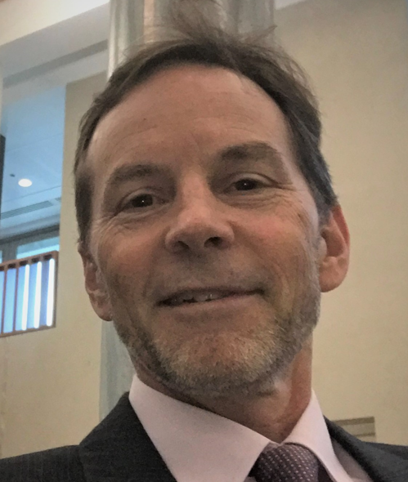
Dr Mitchell Smith

Dr Mitchell Smith is a public health physician involved in the health care of refugees for over 30 years, both overseas and in Australia. Since 1999 he has been Director of the NSW Refugee Health Service, where he oversees clinical programs, health education, teaching
Dr Smith provides advice on refugee health policy at state and national levels.

He was recently seconded for 9 months to support the COVID-19 response in South Western Sydney.

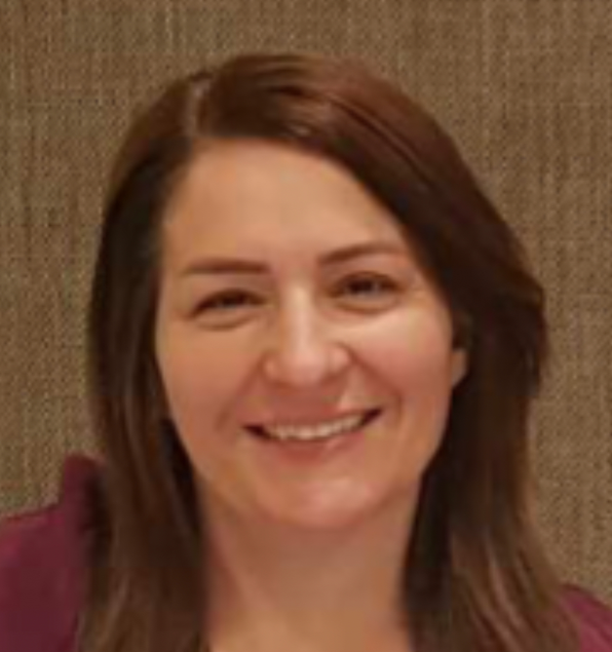

Ms Sundus Yousif

Born in Baghdad, Iraq. Chaldean by background and speaks Arabic and Chaldean. Has Bachelor’s Degree in Medicine and General surgery from Al - Mustansiriya University in Baghdad.

As a doctor, worked at various hospitals in Iraq. Moved to a village close to Mosul (North Iraq) after fall of Saddam Hussein regime. Worked as a permanent resident doctor in a Gynaecology and Obstetrics Hospital. Then operated her own private GP clinic in this village. For 12 years, was mostly the only doctor in the village of 600 families.

In 2014 was forced by ISIS threat to move to Dohuk in the Kurdistan area of Northern Iraq. Worked as a GP providing medical help to the Yazidi community for a year.

In 2015 with her husband and 4 daughters, moved to Jordan. Stayed one year before her sister in Australia sponsored the family on a humanitarian visa. Arrived in Australia in November 2016.

Studied English, then worked as a volunteer in Public Schools as a School Learning Support officer. Also, at the Salvation Army to facilitate English conversation classes.

In 2019, trained as a Bilingual Community Educator (BCE) with the NSW Refugee Health Service (RHS). Works on a contractual base, delivering health information in language to the Arabic and Chaldean speaking community. She provides information on topics including Navigating the Health Care System, Oral Health, Cancer Screening and other preventive programs, Women’s Health, and Covid-19.

During the COVID-19 pandemic she worked at testing and vaccination clinics as a language support officer, helped the Arabic and Chaldean/Assyrian speaking communities with booking COVID -19 vaccinations, and sharing online information in different languages.

